Scenario 1: Student Academic Performance Dashboard
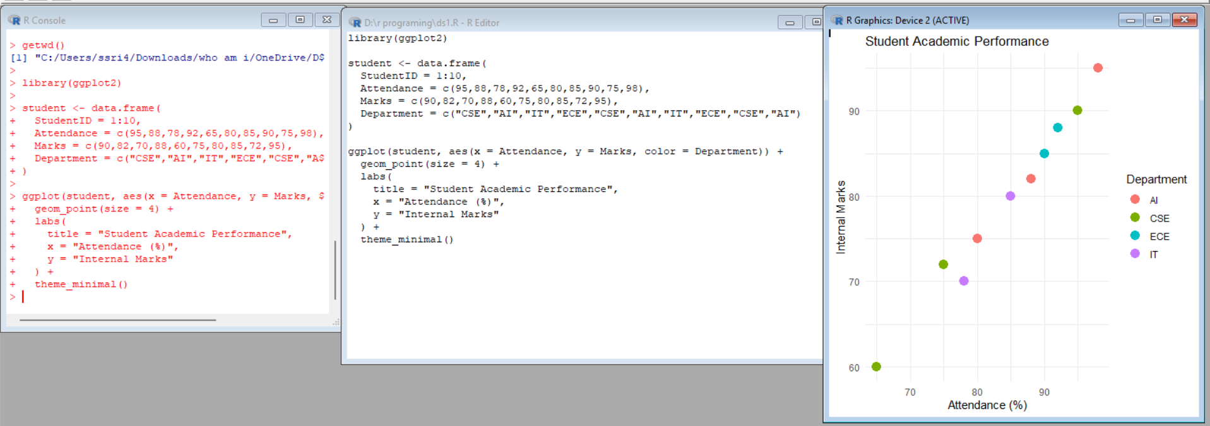
Scenario 2: Electric Vehicle Market Analysis
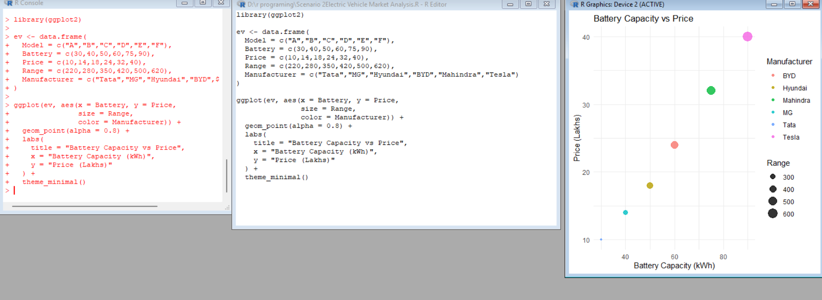

Scenario 3: Hospital Patient Admission Analysis
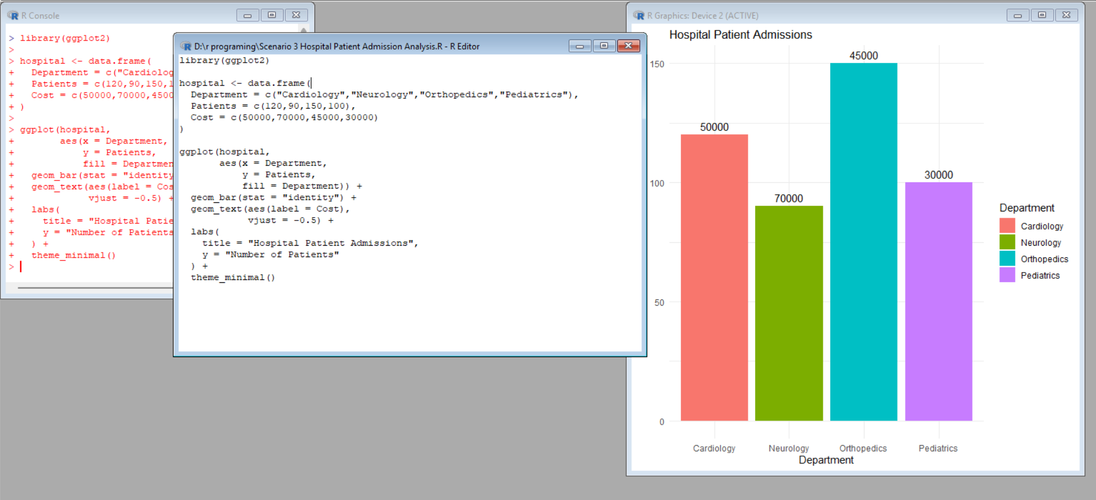 Scenario 4: Weather Monitoring System
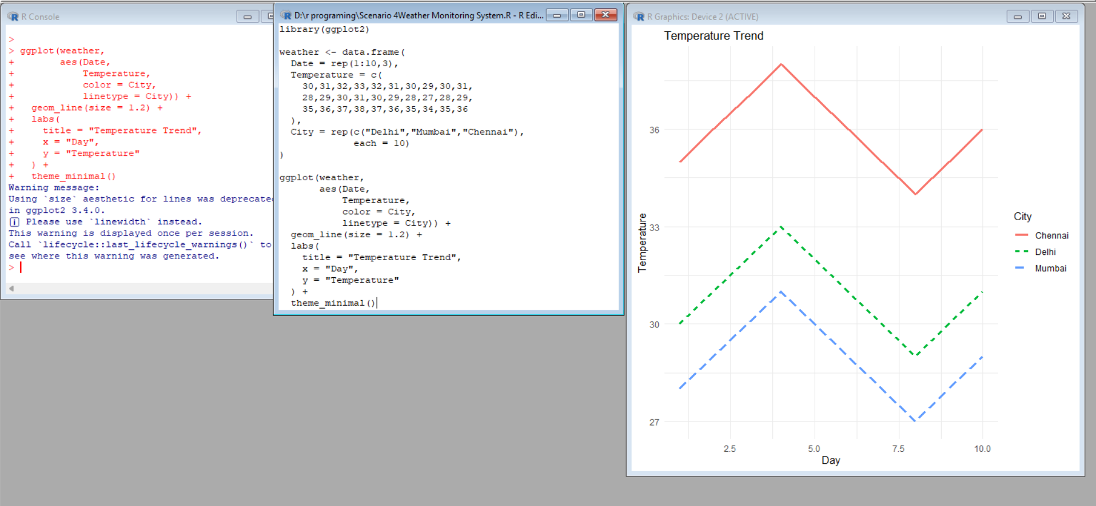

Scenario 5: Supermarket Sales Analysis
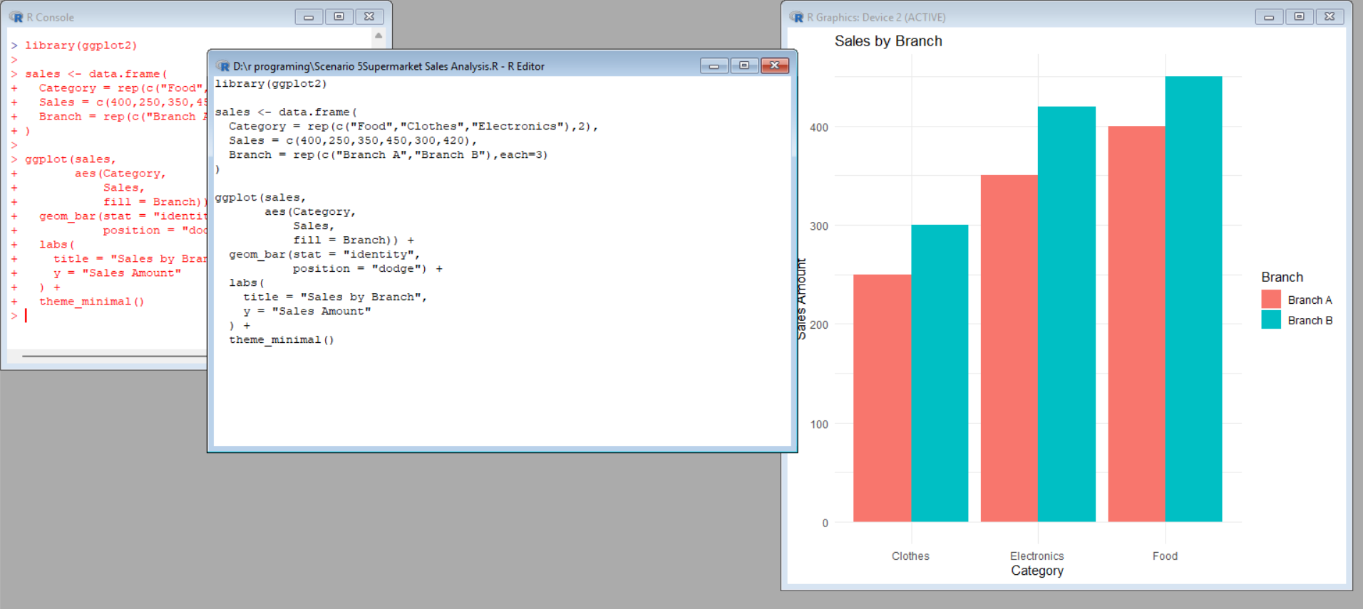

Scenario 6: Employee Salary Distribution
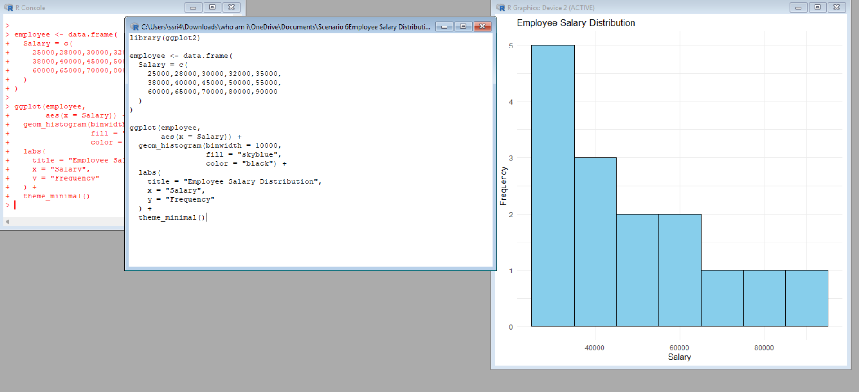
Scenario 7: Smartphone Market Comparison
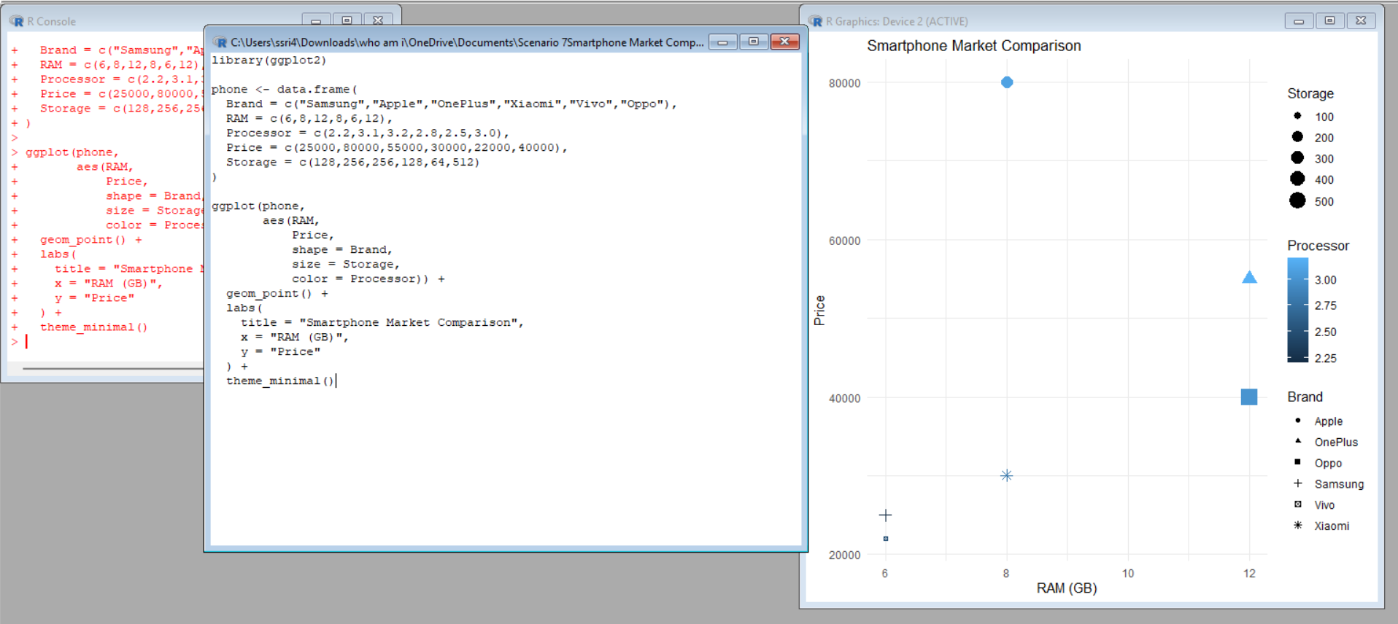

Scenario 8: Online Movie Rating Analysis
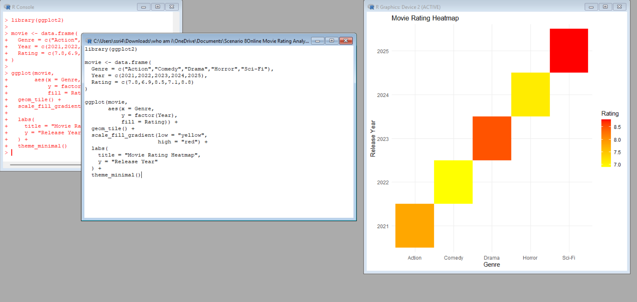

Scenario 9: COVID-19 State-wise Analysis (Tile Plot)
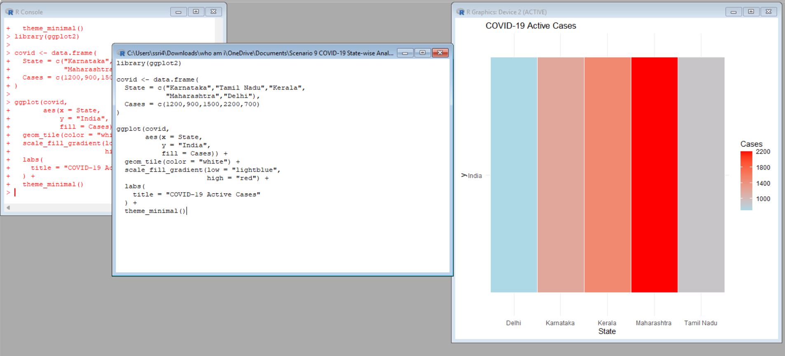

Scenario 10: Iris Flower Classification
